SOUTHERN RIVER COLLEGE
Human Biological Science
Unit 3 & 4

TASK 10 – Test 4
Evolution

Time: 60 mins

Multiple Choice: 10 marks
Short Answer: 30 marks
Extended Answer: 10 marks
TOTAL 50 MARKS

Weighting: 5%
Do not write on this question booklet
Do not turn page until instructed to do so

Section A: Multiple Choice (10 Marks)

Answer all questions by placing an X through the most correct answer on the multiple choice answer sheet.

Questions 1 and 2 refer to the diagram shown below
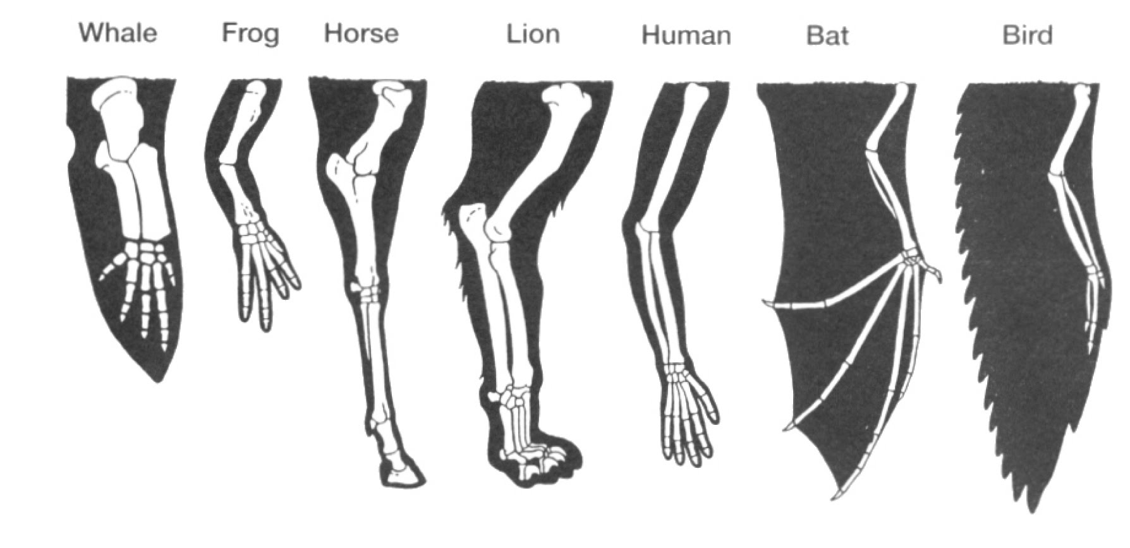

- The name given to the type of evidence of evolution shown in the diagram is

- comparative embryology.
- homologous structures.
- vestigial organs.
- analogous characteristics.

- The best explanation for the evidence of evolution shown in the diagram is that

- the bird and the bat both use the limb as a wing to fly. The bird and the bat must have the more recent common ancestor than the other vertebrates.
- all the limbs have evolved along different pathways, with the similarity due to coincidence. No relationship is supported by the evidence.
- the highly-specialised limb of the horse makes it the most different from all the others. The horse must be the most distantly related to the other vertebrates.
- all the limbs display a similar structure but function differently. All of these vertebrates must have shared a common ancestor at some point in time.

- Artefacts differ from fossils in that artefacts:

(a) are found associated with human remains
(b) are made of organic material that can be carbon dated
(c) are objects produced by hominins for a particular purpose
(d) are works of art with religious significance

Question 4 refers to the diagram below of the half-life of Potassium (K)-40.

- Potassium-40 decays into Argon-40. If a sample was found to be 3.2 billion years old, what approximate percentage of Argon-40 would be present?

(a) 80%
(b) 90%
(c) 60%
(d) 40%

- The half-life of Carbon-14 is approximately:

(a) 10 430 years.
(b) 7250 years.
(c) 5730 years.
(d) 4780 years.

- The following statements (not in correct order) summarise the steps in natural
selection.

1. Some individuals are better suited to a particular environment.
2. Over time there is an increase in particular characteristics in the population.
3. There is variation within a population, some of which is genetic.
4. Individuals better suited to the environment are more successful at survival and reproduction.

The order of statements which best describe natural selection are

- 1, 3, 2, 4
- 3, 1, 4, 2
- 2, 3, 1, 4
- 1, 2, 4, 3

- In certain industrial parts of England a certain light coloured moth (Biston betularia) which normally invisible against the pale bark on the trees has now developed a very dark form of the species. This Dark coloured moth in a matter of a few years has become more successful than the light-coloured moth.
Which is the likeliest reason?
- The dark moth no longer rests on trees but on dark rocks, also widely present in the moth's habitat.
- Due to the local industry pollutants the trees have become soot-coloured.
- The dark moth competes more successfully for food.
- The dark moth breeds more rapidly than the light coloured moth.

- How has the dark moth (mentioned in question 9 above) arisen in numbers?
- By natural selection
- By mutation
- By geographical isolation
- By adaptation.

Question’s 9 and 10 refer to the diagram of strata (layers) below.
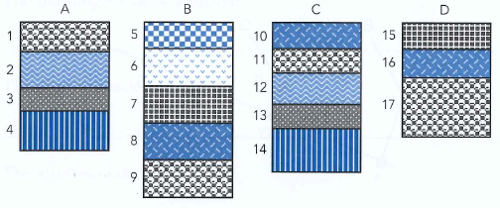
9. In which section would we find the oldest stratum (layer) at the surface?

(a) A
(b) B
(c) C
(d) D

10. Which of the following statements is incorrect concerning the above strata

(a) B8 is older than D15.
(b) A4 is the same age as C14.
(c) A1 is the same age as B9.
(d) D15 is younger than B6.

End of Section A

Name _________________________________________
Teacher_________________________________________

SOUTHERN RIVER COLLEGE
Human Biological Science Unit 3 & 4

TASK 10 – Test 4 Evolution

TOTAL / 50 MARKS

Multiple choice & answer booklet

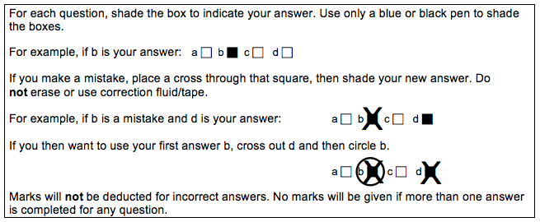

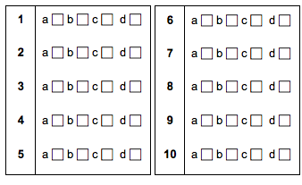
Section B: Short Answer (30 Marks)

Answer all questions in the spaces provided.
Question 11 (9 marks)

Part (a) of the question refers to the diagram below.
Coccyx
Appendix
Wisdom Teeth

The structures shown in the diagram provide evidence for evolution.
(a) (i) What collective name is given to the structures shown in the diagram?
(1 mark)
Description | Marks
Vestigal Organs | 1

(ii) Provide another example of a structure in the human body that could be classified in the same category as those shown in the diagram.
(1 mark)
Description | Marks
body hair /nictitating membrane of the eye/pointed canine teeth/segmented abdomen muscles/pyramidalis muscle/piloerector muscles/tonsils/darwins point on ear/ear muscles/any other structure | 1

(iii) Explain how the structures shown in the diagram could provide evidence for evolution. (3 marks)
Any 3 of the following:
Description | Marks
The structures are remains of organs that were required in ancestral forms | 1
Natural selection pressures have reduced the organs/natural selection pressures have made them non-functional | 1
No longer essential/body does not waste energy on maintaining structures | 1
Suggests ancestral relationship/common ancestor with organisms that have functional forms of the same organs

Part (b) of the question refers to the diagram below.
(b) (i) What name is given to the type of evidence for evolution represented in the
diagram?
(1 mark)
Description | Marks
Comparative embryology/developmental anatomy | 1

(ii) Describe how the evidence shown in the diagram provides support for the theory of evolution.
(1 mark)
Any 1 of the following:
Description | Marks
Closely related organisms show more similar anatomical development in the embryonic/early stages of life | 1
More distantly related organisms show greater differences anatomy/earlier differences in embryonic development | 1

(iii) Could a similar diagram be drawn to include humans as an example in the same category as the three organisms shown in the diagram above? Justify your answer.
(2 marks)
Description | Marks
Must Have:  Yes | 1
And 1 justification:  - It is a vertebrate  - It shows similar embryonic stages/stages of early life  - Embryos of organisms (vertebrates) are easy to compare at an early stage | 1

Question 12 (11 marks)

The graph below indicates the temperatures at which different parts of the polymerase chain reaction (PCR) cycle occur.
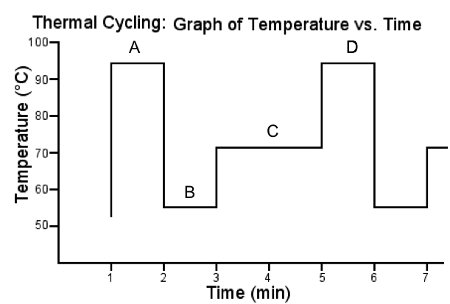

- Give the names of each of the temperature phases as shown in the graph above:
(2 marks)

A DENATURING B ANNEALING

C ELONGATION D DENATURING

- Why is the temperature required to be so high at section A on the graph?
(1 mark)
Description | Marks
To denature the DNA strand/separate the double stranded DNA into two single strands  OR  To break the weak hydrogen bonds between complementary bases | 1

- (i) What section of the graph is DNA polymerase involved in? (1 mark)

Description | Marks
Section C | 1

(ii) Is DNA polymerase the most appropriate enzyme? Explain why and include in your response what you would add instead. (2 marks)

Description | Marks
No, as it denatures under high temperatures | 1
Taq polymerase | 1

(iii) Describe the role of DNA polymerase. (2 marks)

Description | Marks
Binds to the primer (DNA template hybrid/combined primer and single DNA strand) | 1
Synthesises a new DNA strand/creates a complementary strand | 1

- PCR and gel electrophoresis are used to assist in the identification of a crime suspect. Explain why you would require both of these processes in forensics. (4 marks)

Description | Marks
PCR: used when there are only very small amounts of DNA available | 1
PCR: produces copies/replicates the small sample (taken from the crime scene) | 1
Gel electrophoresis: produces a DNA profile/fingerprint (of the suspect) | 1
This sample then be compared against other suspects/individuals involved | 1

- Explain how gel electrophoresis works.
(5 marks)

Description | Marks
DNA pieces are placed in the wells of the agarose gel | 1
An electric current is passed through the gel/a voltage is applied across the gel | 1
DNA is negatively charged so moves through the gel to the positive electrode | 1
The smaller pieces have less resistance and so move faster through the gel  OR  The larger pieces experience more resistance and so move slower through the gel | 1
Bands form/DNA profile forms/DNA fingerprint/patterns | 1

Question 13 (4 marks)

There are many types of comparative studies that can be used to support the theory of evolution. Two of these involve studies in biochemistry, protein sequences and DNA.
Describe how protein sequences provide evidence for evolution.
Description | Marks
Proteins made of long chains of animo acids | 1-3
Determine type and sequence of animo acids/describe method of sequencing | 1-3
Western blotting to detect specific proteins in a sample | 1-3
Using similar/ubiquitous proteins (e.g. cytochrome c) in different species | 1-3
Compare sequence in different species | 1-3
Must have one point for explaining how:  Secies that are distantly related have more differences in their amino acid sequence/closely related more similarities/more time has passed since common ancestry | 1

End of Section B

Section C: Extended Answer (10 Marks)

Select ONE of the following questions, and answer below.

Question A

Discuss the importance of the fossil record in providing evidence for evolution. In your answer, include how fossils form and how the information they provide can be interpreted. (10 marks)

Question A: Answer

Description | Marks
Any 1 of the following:  Importance:  (1) Shows change over time  (1) Evidence of the missing link  (1) Can be used in conjunction with other evidence ie. DNA/comparative anatomy etc. (must provide an example) | 1
Any 3 of the following:  How formed:  (1) Rapid burial by fine sediment/volcanic ash  (1) Mineralisation: organic material replaced with minerals (in the soil)  (1) Acid and low oxygen for soft tissue  (1) Alkaline and low oxygen for bone  (1) Preserved in amber | 3
Relative Dating | 1
Any 2 of the following:  (1) Superposition  (1) Comparative stratigraphy  (1) Index fossils  (1) Fluorine | 2
Absolute Dating | 1
Any 2 of the following:  (1) Carbon -14  (1) Potassium-Argon  (1) Dendrochonology | 2

OR

QUESTION B

Describe how vaccines could be produced by recombinant DNA techniques
(10 marks)

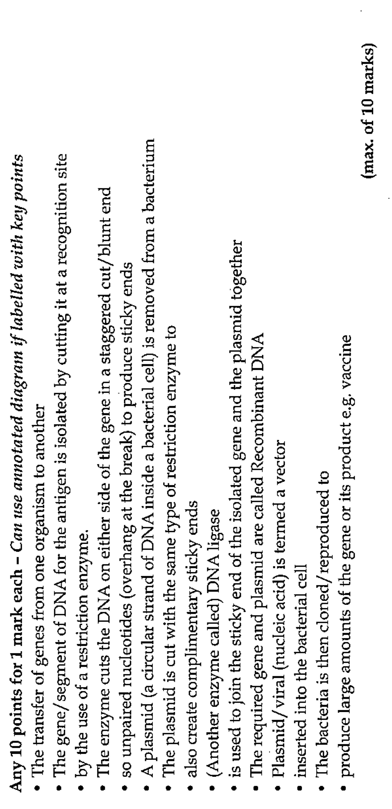
Question B: Answer

Question A (OLD):

Examining fossils and their surroundings is one method by which evolution can be shown to have occurred. However there are also many types of comparative studies that can be used to support the theory of evolution. Two of these involve studies in biochemistry, namely protein sequences and DNA. Describe the two comparative studies of protein sequences and DNA, and explain how they show evidence for evolution.
(10 marks)

